**PRACTICAL NO.6**

**Programming menus, dialog, dialog fragments**

**Code:**

**activity_main.xml**

<?xml version="1.0" encoding="utf-8"?>  
<androidx.constraintlayout.widget.ConstraintLayout xmlns:android="http://schemas.android.com/apk/res/android"  
 xmlns:app="http://schemas.android.com/apk/res-auto"  
 xmlns:tools="http://schemas.android.com/tools"  
 android:layout_width="match_parent"  
 android:layout_height="match_parent"  
 android:id="@+id/mylay"  
 tools:context=".MainActivity">  
  
 <Button  
 android:id="@+id/button"  
 android:layout_width="wrap_content"  
 android:layout_height="wrap_content"  
 android:text="Menu"  
 app:layout_constraintBottom_toBottomOf="parent"  
 app:layout_constraintEnd_toEndOf="parent"  
 app:layout_constraintHorizontal_bias="0.498"  
 app:layout_constraintStart_toStartOf="parent"  
 app:layout_constraintTop_toTopOf="parent"  
 app:layout_constraintVertical_bias="0.175" />  
  
 <Button  
 android:id="@+id/button2"  
 android:layout_width="wrap_content"  
 android:layout_height="wrap_content"  
 android:text="Color Change Dialog"  
 app:layout_constraintBottom_toBottomOf="parent"  
 app:layout_constraintEnd_toEndOf="parent"  
 app:layout_constraintHorizontal_bias="0.498"  
 app:layout_constraintStart_toStartOf="parent"  
 app:layout_constraintTop_toTopOf="parent"  
 app:layout_constraintVertical_bias="0.364" />  
  
 <Button  
 android:id="@+id/button3"  
 android:layout_width="wrap_content"  
 android:layout_height="wrap_content"  
 android:text="Custom Dialog"  
 app:layout_constraintBottom_toBottomOf="parent"  
 app:layout_constraintEnd_toEndOf="parent"  
 app:layout_constraintHorizontal_bias="0.498"  
 app:layout_constraintStart_toStartOf="parent"  
 app:layout_constraintTop_toTopOf="parent"  
 app:layout_constraintVertical_bias="0.559" />  
</androidx.constraintlayout.widget.ConstraintLayout>

**MainActivity.kt**

package com.example.firstdemo  
class MainActivity : AppCompatActivity() {  
 override fun onCreate(savedInstanceState: Bundle?) {  
 super.onCreate(savedInstanceState)  
 setContentView(R.layout.activity_main)

*//on button press menu*  
 button.setOnClickListener {  
 var mymenubtn=PopupMenu(this,button)  
 menuInflater.inflate(R.menu.my_menu,mymenubtn.menu)  
 mymenubtn.show()  
  
 mymenubtn.setOnMenuItemClickListener(  
 PopupMenu.OnMenuItemClickListener { it ->  
 when(it.itemId){  
 R.id.i1->mylay.setBackgroundColor(Color.CYAN)  
 R.id.i2->Toast.makeText(this,"Hello SRM",Toast.LENGTH_SHORT).show()  
 R.id.i3->System.exit(0)  
 }  
 true  
 }  
 )  
 }

*//on button pressed dialog*  
 button2.setOnClickListener {  
 var alert_box=AlertDialog.Builder(this)  
 alert_box.setTitle("Change Color")  
 alert_box.setMessage("Do you want change color?")  
 alert_box.setPositiveButton("Yes"){  
 alert_box,it->mylay.setBackgroundColor(Color.YELLOW)  
 }  
 alert_box.setNegativeButton("No"){  
 alert_box,it->Toast.makeText(this,"No Change",Toast.LENGTH_SHORT).show()  
 }  
 alert_box.setNeutralButton("Nothing"){  
 alert_box,it->Toast.makeText(this,"Nothing",Toast.LENGTH_SHORT).show()  
 }  
 alert_box.create()  
 alert_box.show()  
 }

*//Custom dialog*  
 button3.setOnClickListener {  
 var obj=MyOwnDialog()  
 obj.show(supportFragmentManager,"MyDialog")  
 }  
 }

*//on back press dialog*  
 override fun onBackPressed() {  
 var alert_box=AlertDialog.Builder(this)  
 alert_box.setTitle("Close")  
 alert_box.setMessage("Do you want close app ?")  
 alert_box.setPositiveButton("Yes"){  
 alert_box,it->System.exit(0)  
 }  
 alert_box.setNegativeButton("No"){  
 alert_box,it->Toast.makeText(this,"No Change",Toast.LENGTH_SHORT).show()  
 }  
 alert_box.setNeutralButton("Nothing"){  
 alert_box,it->Toast.makeText(this,"Nothing",Toast.LENGTH_SHORT).show()  
 }  
 alert_box.create()  
 alert_box.show()  
 }

*//Simple menu*  
 override fun onCreateOptionsMenu(menu: Menu?): Boolean {  
 menuInflater.inflate(R.menu.my_menu,menu)  
 return true  
 }  
 override fun onOptionsItemSelected(item: MenuItem): Boolean {  
 if(item.itemId==R.id.i1){  
 mylay.setBackgroundColor(Color.MAGENTA)  
 }  
 if(item.itemId==R.id.i2){  
 Toast.makeText(this,"Hello SRM",Toast.LENGTH_SHORT).show()  
 }  
 if(item.itemId==R.id.i3){  
 System.exit(0)  
 }  
 return true  
 }  
}

**my_menu.xml:**

<?xml version="1.0" encoding="utf-8"?>  
<menu xmlns:android="http://schemas.android.com/apk/res/android">  
 <item android:id="@+id/main"  
 android:title="Main Menu">  
 <menu>  
 <item android:id="@+id/i1"  
 android:title="Change Color"/>  
 <item android:id="@+id/i2"  
 android:title="Toast"/>  
 <item android:id="@+id/i3"  
 android:title="Exit"/>  
 <item android:id="@+id/dis"  
 android:title="Option"  
 android:enabled="false" />  
 </menu>  
 </item>  
</menu>

**my_dialog.xml:**

<?xml version="1.0" encoding="utf-8"?>  
<AbsoluteLayout xmlns:android="http://schemas.android.com/apk/res/android"  
 android:layout_width="match_parent"  
 android:layout_height="match_parent">  
  
 <EditText  
 android:layout_width="300dp"  
 android:layout_height="wrap_content"  
 android:id="@+id/txt"  
 android:hint="Enter your data:"/>  
  
 <Button  
 android:layout_width="wrap_content"  
 android:layout_height="wrap_content"  
 android:id="@+id/btnsubmit"  
 android:layout_x="120dp"  
 android:layout_y="50dp"  
 android:text="Submit"/>  
</AbsoluteLayout>

**MyOwnDialog.kt:**

package com.example.firstdemo  
class MyOwnDialog:DialogFragment() {  
 override fun onCreateView(  
 inflater: LayoutInflater,  
 container: ViewGroup?,  
 savedInstanceState: Bundle?  
 ): View? {  
 var main=inflater.inflate(R.layout.my_dialog,container)  
 main.btnsubmit.setOnClickListener {  
 var data=main.txt.text.toString()  
 Toast.makeText(context,data,Toast.LENGTH_SHORT).show()  
 }  
 return main  
 }  
}

**Output:**

**Simple Menu and Button Menu -**

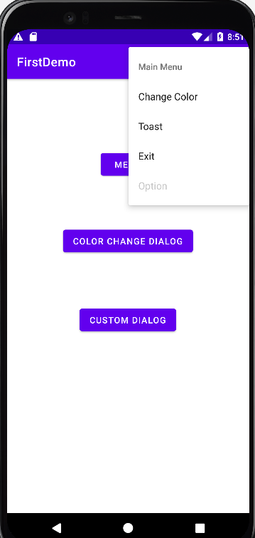 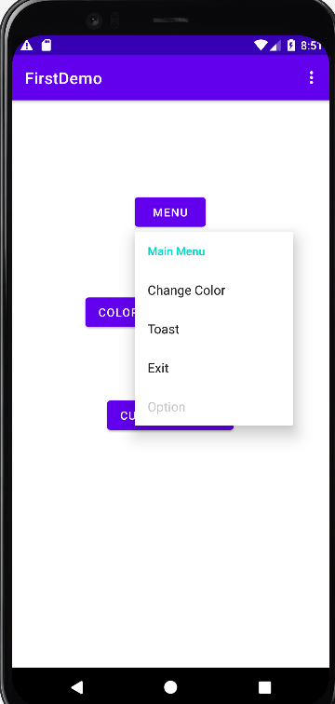

**Button Pressed simple Alert Dialog Box-**

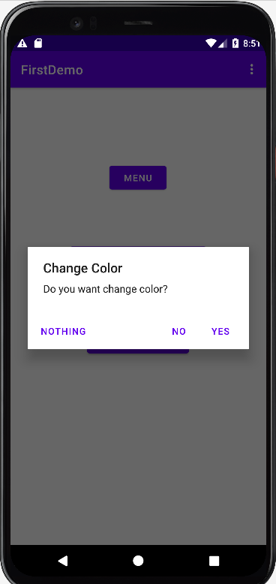 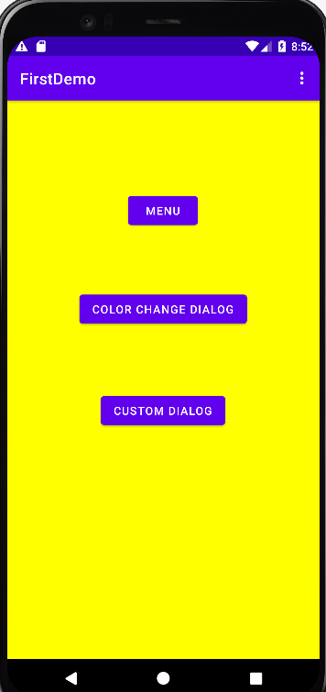

**BackPress Alert Dialog Box-**

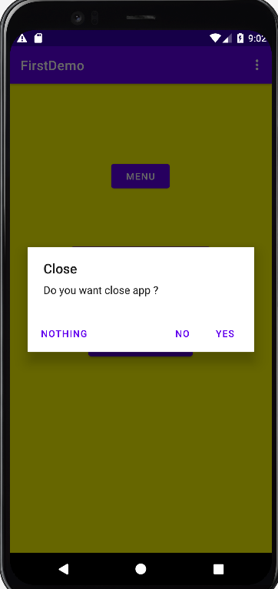 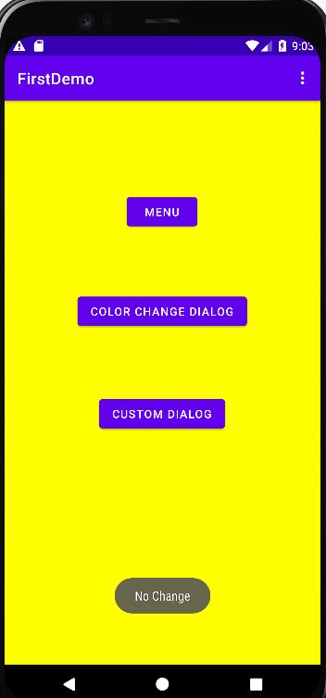

**Custom Dialog Box-**

